# Apply filters to SQL queries

## Project description

[I was presented with various real world use cases in which sql would be used.

I then was presented with the task of coming up with queries that would offer insight to these various scenarios. ]

## Retrieve after hours failed login attempts

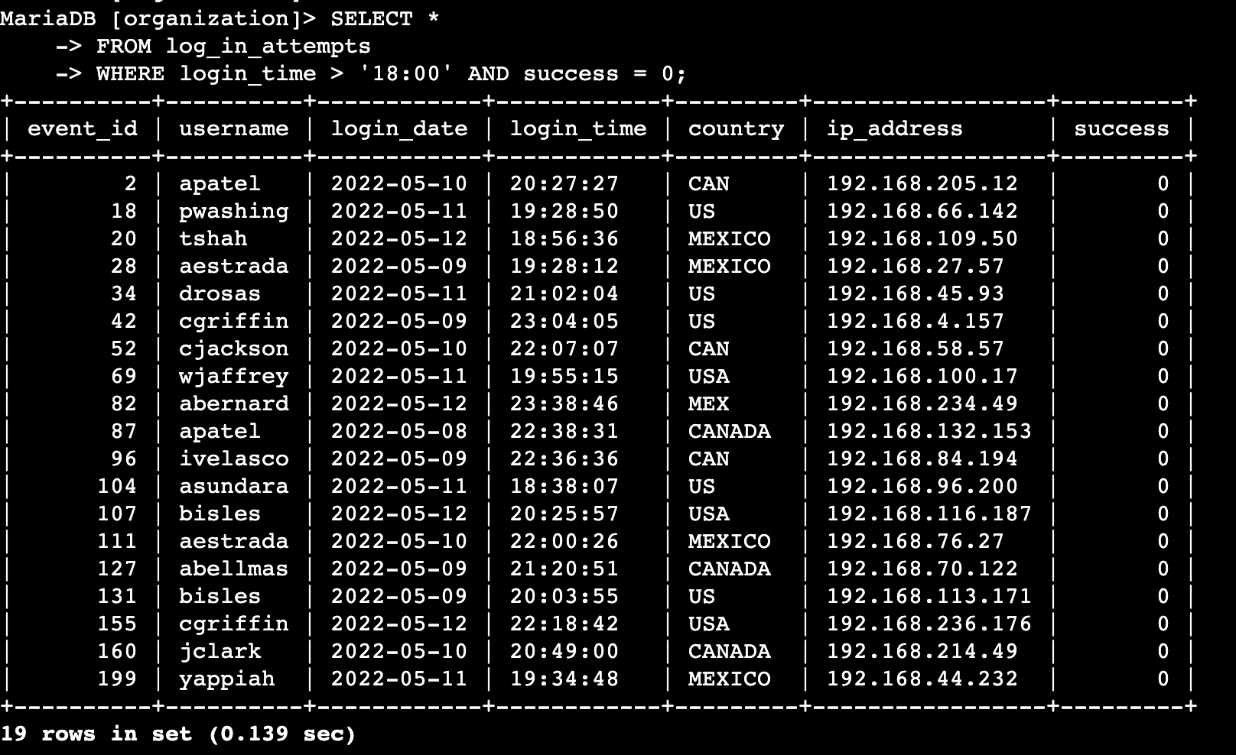[The scenario here was about the discovery about a potential security incident that happened after business hours.

I was able to accomplish this by first telling sql that i wanted to pull all data from the log_in_attempts table where the login was attempted after hours.

* This translates to the “ Select * “ that can be seen in the screenshot above
* From log_in_attempts ,This lets sql the table i would like the data pulled from
* WHERE login_time> ‘18:00’ And success = 0 . I applied the greater than operator because the incident happened after hours and after hours for this company starts at 6pm also ,the format for sql i the 24 hour format so thats why it reads “18:00” ]

## Retrieve login attempts on specific dates

[For this scenario i got some practice using or filters . The details of this scenario was that there was suspicious event that occurred on 2022-05-09. You want to retrieve all login attempts that occurred on this day and the day before (2022-05-08).

For this scenario the query that i used was

SELECT *

FROM log_in_attempts

WHERE login_date = '2022-05-08' OR login_date = '2022-05-09';

And the output that i received was 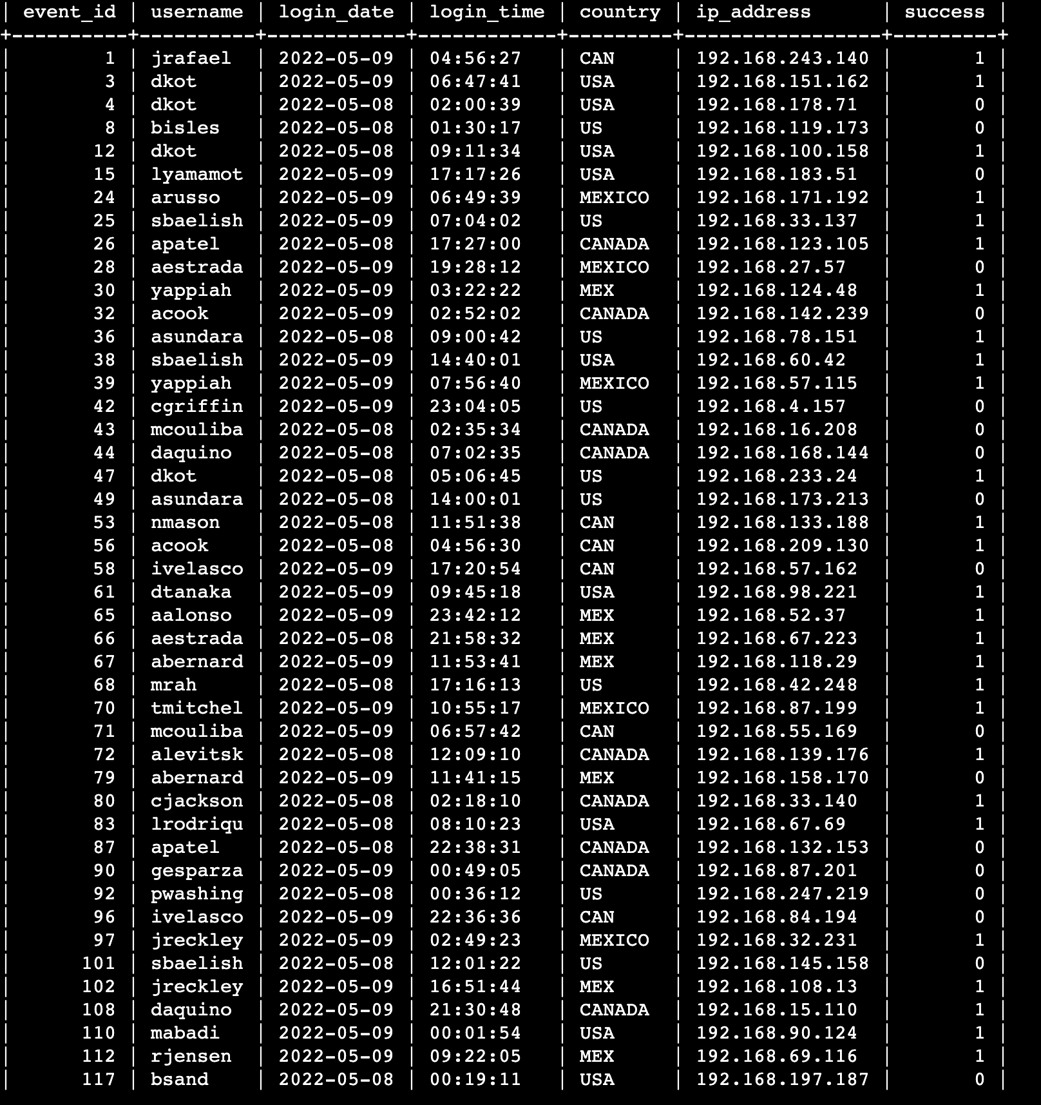

## Retrieve login attempts outside of Mexico

[This scenario gave me great hands on experience with the Not filter

The query that i used here was

SELECT * = Select all columns on the table

FROM log_in_attempts = select all columns from the log_in_attempts table

WHERE NOT country LIKE ‘Mex%'; = Return all values from log_in_attempts table where the country is not mexico

The output

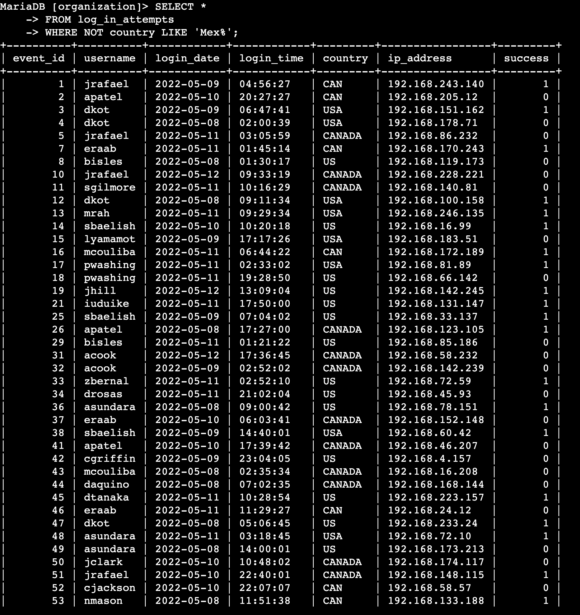

## Retrieve employees in Marketing

For this scenario the task was to find all the employees in the marketing department that reside in all east offices because their machines need an update

The query that i used here was

* Select* = select all information from a table
* From employees = this is telling sql that the information that i'm looking for is in this table.
* Where office like ‘East-%’ and department = ‘Marketing’ : This lets sql know that i'm looking for all of the information in the employee tables when the office is in the east and the employees are in the marketing department.

The output

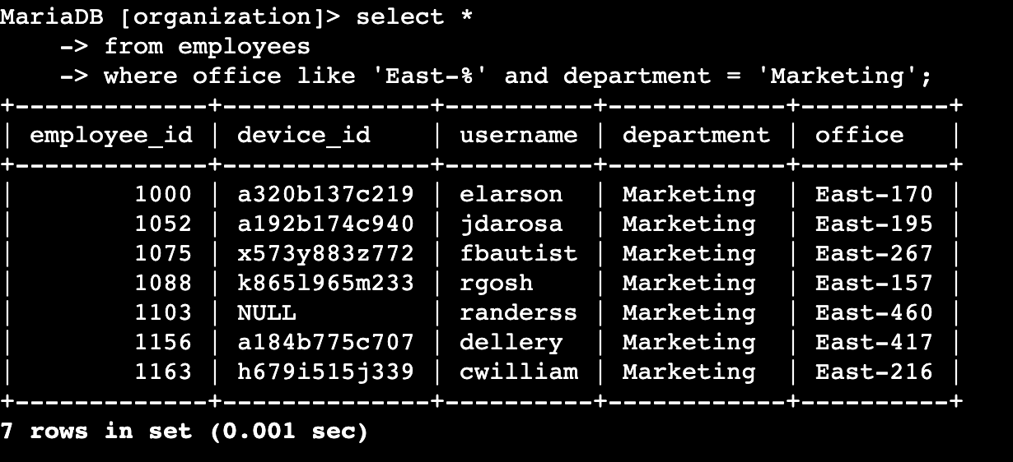

## Retrieve employees in Finance or Sales

For this scenario the company needs to perform updates on the devices of employees for the finance and sales departments.

The query that i used here was

* Select* = Select all the information
* From employees = selecting all information from the employees table
* Where department = ‘Finance’ or ‘Sales’ : This lets sql that i would like to access all the for the employees in the finance or sales departments

The output

## 

## Retrieve all employees not in IT

So the company gave the employees in the IT department an early update and now its time to get everyone else up to date and the company needs to know what departments and devices need to be updated

The query that i used here is

Select* = Selects all information From a table

From employees = selects all information from the employees table

Where not department = ‘Information Technology’ : This command lets sql know that i want all information from the employees table that is not from the IT department .

The output

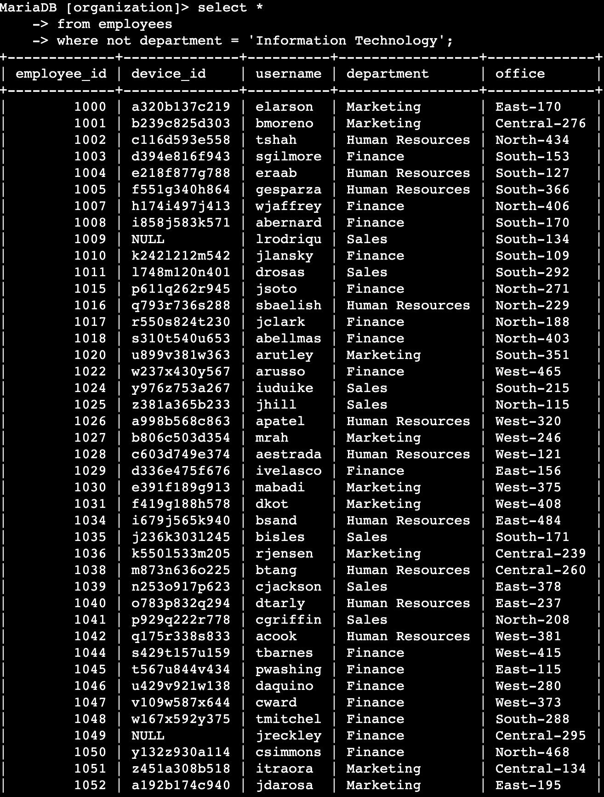

## Summary

I was able to get alot of hands on experience using sql with real life scenarios that i might see in an entry level security role. I was able to use filters such as where , like , OR, and between. To make queries that returned the right amount of information. I also utilized things like patter filters . This was a great way to display my understanding of sql.